Coming Soon Race Days

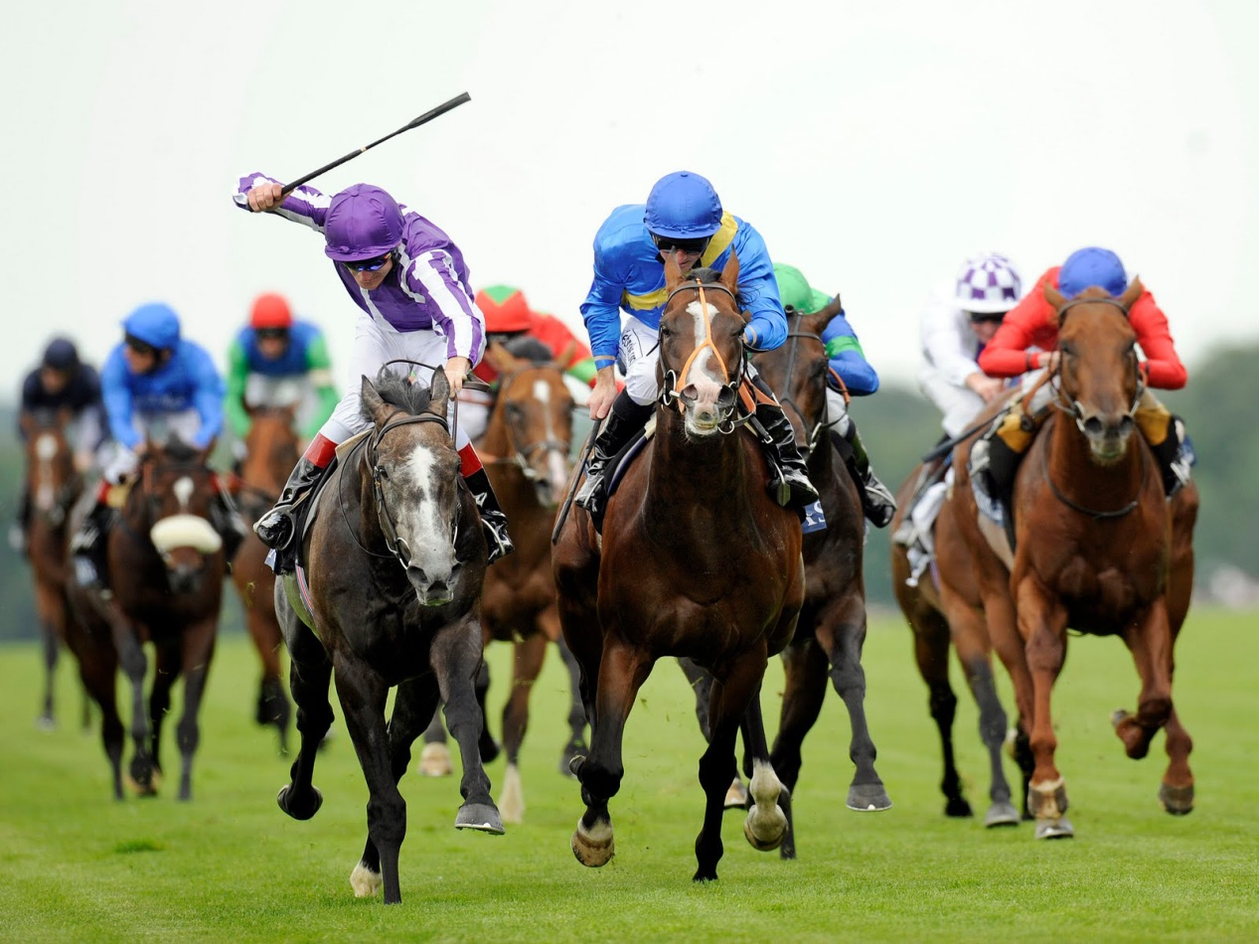

Coach Only Day trips to Popular Race Course

**Tues 27th December Chepstow Welch Grand National**